Government Allocates D30 Million to Victims Reparation Commission to Advance Justice for Victims
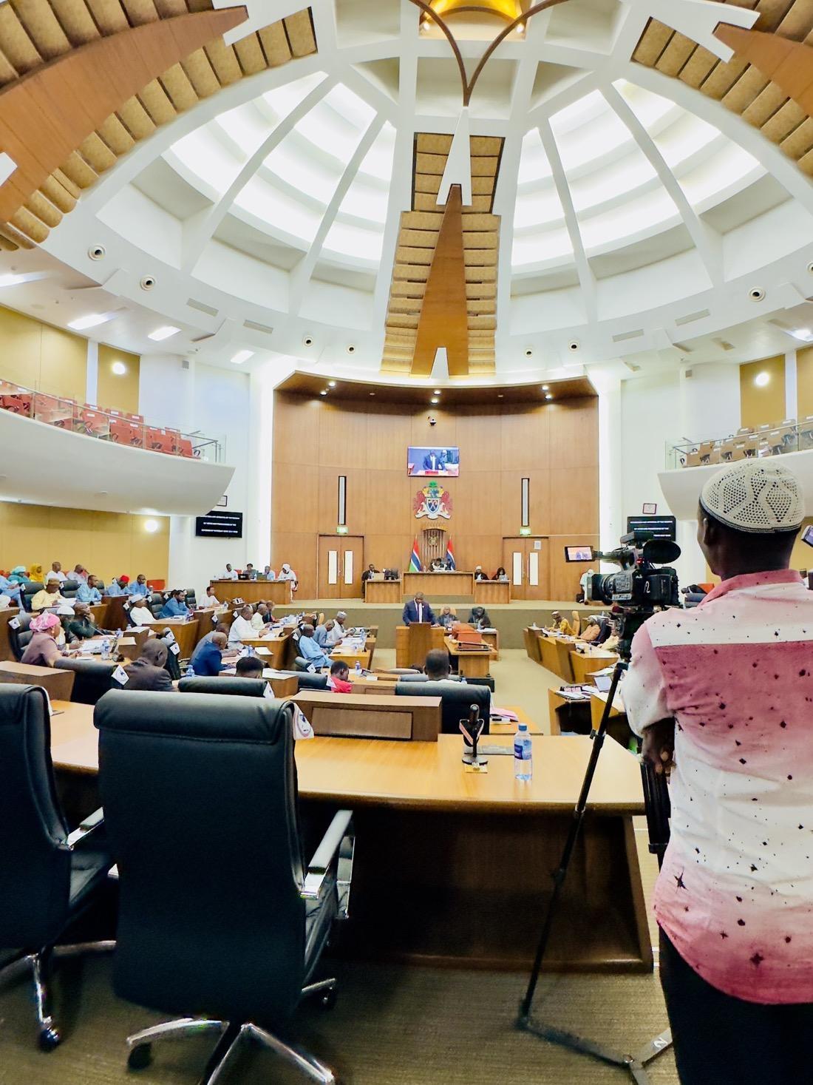

The Ministry of Justice informs the public that D30 million has been allocated to the Victims Reparation Commission (VRC) to advance the reparations process for victims of past human rights violations. This announcement was made by the Attorney General and Minister of Justice, Hon. Dawda A. Jallow, during the Third Ordinary Session of the National Assembly in the 2025 Legislative Year, held on Wednesday, 10th September 2025.
The statement was delivered in response to questions raised by members of the National Assembly during the oral question segment of the sitting. The Attorney General explained that D20 million has been earmarked for direct reparations to victims, while D10 million has been allocated for the operational needs of the Commission.
From the operational allocation, D5, 320, 940 out of the 10 millions allocation has already been released by the Ministry of Finance to facilitate the establishment of the Commission. In addition, D17.5 million from the reparations fund has been disbursed. The Attorney General clarified that while these funds are available, the actual payment of reparations has not yet commenced, as the Commission is finalizing its internal policies, strategies, and eligibility criteria to ensure a credible and transparent process.
The Ministry of Justice acknowledges the endurance and resilience of victims who have waited for this process. It recognizes that no form of compensation can erase the harm suffered. However, reparations are a necessary step toward recognition, justice, and restoration.
The establishment of the VRC is an important milestone in the implementation of the recommendations of the Truth, Reconciliation and Reparations Commission (TRRC). It reflects the Government’s determination to uphold justice, promote national reconciliation, and guarantee that victims remain at the centre of the transitional justice process.
The Ministry assures victims that reparations will be managed with integrity, transparency, and accountability, and that the resources allocated will be directed to those who are eligible. It further encourages all Gambians to view this process as a step towards consolidating peace and strengthening national unity.

